How the youngest children are left behind in humanitarian response

# *Insert image of family with young children in a refugee resettlement. E.g. photo on page 20* [*here*](https://www.rescue.org/sites/default/files/document/4803/irc-rul-reportapril27-2020revised-2-10-22.pdf)*.*

Because of the protracted nature of many emergencies—many of which last between 10 and 26 years—millions of young children spend the entirety of their childhoods in crisis contexts that threaten their short and long-term development ([Masten and Narayan](https://pubmed.ncbi.nlm.nih.gov/21943168/) 2012). Children’s earliest experiences shape the architecture of the brain and determine their future development. When a child is born into an emergency context or experiences severe adversity before the age of five, they face compounding risks that threaten their long-term development and well-being. Unfortunately, there is a large gap in the humanitarian response aimed at mitigating the negative consequences emergencies have on displaced infants, toddlers, and their caregivers.

Humanitarian programming for the early years cut across several sectors -- health, nutrition, education, WASH, protection -- making it difficult for this topic to find a clear home in a heavily siloed humanitarian system. As a result, early childhood development often falls through the cracks or ends up being delivered on the periphery, as opposed to being woven into standard operating procedure across sectors. Young children’s health, nutritional, learning, safety and socio-emotional needs are closely intertwined. When one need is unfulfilled, it can cause problems in all aspects of a child’s growth and development.

What is early childhood development?

In the first few years of a child’s life, the human brain undergoes the most active period of growth and learning. It forms more than one million new neural connections every second. Both a child’s genes and experiences shape the architecture of the developing brain. Nurturing, stable relationships with caregivers and other adults is an essential ingredient in this process, supporting development of critical social, emotional, and cognitive skills ([Harvard Center on the Developing Child](https://developingchild.harvard.edu/science/key-concepts/brain-architecture/) 2022). Without these consistent, responsive relationships and stimulation during the early years, a child’s healthy development and well-being are threatened.

For the 1 in 5 babies born into conflict-affected areas each year, environmental factors severely threaten their healthy brain development ([UNICEF](https://www.unicef.org/stories/born-conflict-threats-beyond-front-lines) 2019). Substantial evidence from neuroscience to economics shows that experiences with severe, prolonged adversity early in life can alter brain development. The result? Negative impacts on health, learning, and behavior across the lifespan. For very young children born into conflict or displacement, the long-term impact can be devastating.

|  |
| --- |
| Early childhood encompasses several distinct developmental phases: conception to birth, birth to 3 years, preschool and pre-primary years—3 years to 5 or 6 years, or the age of school entry ([UNICEF](https://sites.unicef.org/earlychildhood/files/FINAL_ECD_Programme_Guidance._September._2017.pdf) 2017). The first 1,000 days, from conception to 24 months, are of particular importance for early brain development. |

These developmental phases contribute to the continuous process by which a child grows, develops skills and abilities. All young children, especially refugees, the marginalized, and those in humanitarian crises, need the opportunity to develop to their fullest potential during these critical years ([UNICEF](https://sites.unicef.org/earlychildhood/files/FINAL_ECD_Programme_Guidance._September._2017.pdf) 2017).

Because early childhood development (ECD) encapsulates so many areas of a child’s life, programs designed to support early childhood development must be multi-sectoral. They require coordination across five domains of child development: stimulation, education, health, nutrition, and protection. They must also incorporate support for parents and caregivers to provide nurturing care. Early childhood development programs should include specific actions to uphold a child’s rights to survival, development, protection, and participation ([Moving Minds Alliance](https://movingmindsalliance.org/wp-content/uploads/2019/12/moving-minds-brief-supporting-the-youngest-refugees-grf2019-web.pdf) 2019).

# The Nurturing Care Framework

Nurturing care provides a framework for helping children both survive and thrive. It refers to the conditions created by policies, programs and services that enable communities and caregivers to protect children from threats that would hinder them from reaching optimal physical and emotional health and development. In emergency and crisis contexts, nurturing care also protects children from the impacts of adversity ([UNICEF et al.](https://nurturing-care.org/wp-content/uploads/2021/06/NC_humanitarian.pdf) 2020). The [Nurturing Care Framework](https://nurturing-care.org/ncf-for-ecd) specifically focuses on pregnancy to age 3 because of the lack of programming that exists for this critical period when a child’s brain is developing.

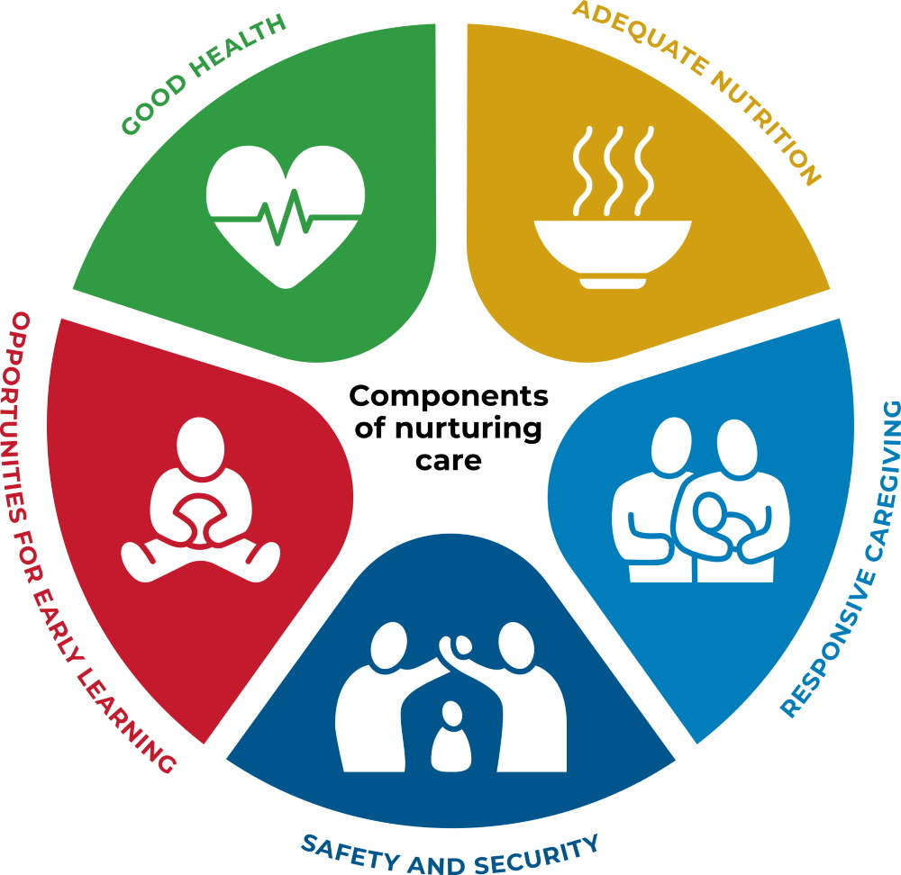

Image Source: [Nurturing Care](https://nurturing-care.org/what-is-nurturing-care/)

The Nurturing Care Framework consists of five components which can be viewed as inputs that are required for achieving optimal development for all young children ([WHO, UNICEF and World Bank](https://nurturing-care.org/ncf-for-ecd) 2018).

1. **Good health.** The health and well-being of children and their caregivers are interconnected.
2. **Adequate nutrition.** Maternal and child nutrition are critical, beginning at conception.
3. **Responsive caregiving.** It is important that a child’s caregiver can notice, understand, and respond to their child’s signals in a timely and appropriate manner.
4. **Opportunities for early learning.** Not just reserved for formal education settings, early learning is any opportunity for the child to interact with a person, place or object in their environment.
5. **Security and safety.** Children and their families need safe and secure environments, free from physical dangers, emotional stress, pollution, and with access to food and water.

Adopting the Nurturing Care Framework is a necessary step in addressing early childhood development in emergency contexts. All five components of the Nurturing Care Framework need to be taken into account to ensure the youngest of children, and their caregivers, are given the support they need to overcome adversity ([UNICEF et al.](https://nurturing-care.org/wp-content/uploads/2021/06/NC_humanitarian.pdf) 2020).

# *Insert image of young child and parent receiving health services in crisis context. E.g. photo on page 32* [*here*](https://theirworld.org/wp-content/uploads/2016/10/Safespaces_report.pdf)*.*

## *Blockquote:* [*More than 29 million babies*](https://www.unicef.org/press-releases/29-million-babies-born-conflict-2018) *were born into areas experiencing armed conflict in 2018, spending their earliest moments in chaos, often in deeply unsafe, and highly stressful environments” (*[*UNICEF*](https://www.unicef.org/stories/born-conflict-threats-beyond-front-lines) *2019).*

.

# Reducing threats with nurturing care

Young children living in crisis contexts face prolonged and excessive stress activation (e.g. toxic stress) that can alter their brain and body chemistry and have detrimental and life-long negative implications. Research shows that access to nurturing care can ameliorate these threats. For the youngest children, a healthy and supportive relationship with a caregiver is the primary source of resilience. Refugee families and families in emergencies, however, face many obstacles to meeting their children’s needs. When caregivers are coping with loss, insecurity, depression, and adversity, their ability to positively engage with their children becomes hindered. This results in an equity gap that begins in early childhood and widens into adulthood (See figure 1).

Consequently, ECD services and programs must incorporate both interventions for young children and preventative care, mental health, and psychosocial support for caregivers. Collectively, these, along with parental coaching, can rebuild a caregiver’s capacity to provide nurturing care for their children and rebuild a healthy family life. Caring for both the young child and the caregiver is currently one of the biggest gaps in existing emergency response efforts.

Figure 1. The child development equity gap

# Recommendations

A growing body of economic evidence demonstrates that investment in effective ECD services can yield some of the greatest public policy returns on investment — particularly for poor, marginalized or conflict-affected communities — for example, by contributing to school readiness and retention, acquisition of qualifications, healthier lifestyles, active citizenship, and social cohesion. However, government investment still tends to prioritize later periods of human development.

The Moving Minds Alliance was founded to provide programmatic, funding, and research expertise to support prioritization of the youngest refugees and their caregivers. It is a multi-stakeholder partnership working to scale up the financing, policies, and leadership needed to effectively support young children and families affected by crisis and displacement everywhere. The need for further partnerships to expand the care for ECD programs and services in humanitarian contexts is great. Here are seven priority actions to help ensure the youngest children, especially those in humanitarian situations, are given the opportunity to grow and develop ([Moving Minds Alliance](https://movingmindsalliance.org/wp-content/uploads/2019/12/moving-minds-brief-supporting-the-youngest-refugees-grf2019-web.pdf) 2019):

1. Prioritize establishing family-centered early childhood programs for all young children and families affected by crisis and displacement.

2. Increase funding for, and explicit and targeted inclusion of, inter-sectoral early childhood programs and services in humanitarian, fragile, and conflict settings, as well as in host communities, resettlement, and return.

3. Establish or strengthen inter-sectoral, inter-agency ECD coordination mechanisms in crisis response.

4. Integrate early childhood interventions into existing services and delivery platforms that reach infants, toddlers, caregivers, and pregnant women.

5. Provide ongoing mental health and psychosocial support as well as parenting support to displaced caregivers raising young children.

6. Engage refugee families and children as active partners in program design and delivery, from identifying needs, to implementing, monitoring, and evaluating impact.

7. Promote ongoing research to better inform early childhood practices affecting children and families affected by displacement, and normalize the collection of age-disaggregated data on both child development and the quality of implemented ECD services.

Adopting a nurturing care lens in humanitarian response strategies can help humanitarian organizations, governments, donors and civil society organizations implement these recommendations and ensure all children have opportunities to thrive.

# References and further reading to learn more

“[Advancing Early Childhood Development: from Science to Scale](https://www.thelancet.com/series/ECD2016),” Linda M. Richter et al. The Lancet Early Childhood Development Series, 2016.

“[Born into conflict: Threats beyond the front lines](https://www.unicef.org/stories/born-conflict-threats-beyond-front-lines).” UNICEF, 2019.

“[Brain Architecture](https://developingchild.harvard.edu/science/key-concepts/brain-architecture/).” Center on the Developing Child website, Harvard University, 2022.

“[Child development in the context of disaster, war, and terrorism: Pathways of risk and resilience](https://pubmed.ncbi.nlm.nih.gov/21943168/).” Masten, A.S. and Narayan, *Annual Review of Psychology,* 63: 227-257, 2012.

[Early Childhood Development and Early Learning for Children in Crisis and Conflict](https://nurturing-care.org/wp-content/uploads/2018/12/UNESCO.pdf). Bouchane, K., Yoshikawa, H., Murphy, K., and Lombardi, J. Background paper to the [2019 Global Education Monitoring Report](http://bitly.com/2019gemreport), UNESCO, 2018.

[Early Childhood Development in Emergencies: Integrated Programme Guide](https://www.unicef.org/earlychildhood/files/Programme_Guide_ECDiE.pdf). UNICEF, 2014.

[Global Trends: Forced Displacement in 2020](https://www.unhcr.org/flagship-reports/globaltrends/). UNHCR, 2020.

[Nurturing care for children living in humanitarian settings](https://nurturing-care.org/wp-content/uploads/2021/06/NC_humanitarian.pdf). UNICEF, International Rescue Committee, WHO, ECDAN and the Partnership for Maternal, newborn & Child Health, 2020.

[Nurturing care for early childhood development: a framework for helping children survive and thrive to transform health and human potential](https://nurturing-care.org/ncf-for-ecd). WHO, UNICEF, World Bank, 2018.

[Safe Spaces: The Urgent Need for Early Childhood Development in Emergencies and Disasters](https://theirworld.org/wp-content/uploads/2016/10/Safespaces_report.pdf). Theirworld, 2016.

[Supporting the Youngest Refugees and Their Families](https://movingmindsalliance.org/wp-content/uploads/2019/12/moving-minds-brief-supporting-the-youngest-refugees-grf2019-web.pdf). Moving Minds Alliance, 2019.

[UNICEF’s Program Guidance for Early Childhood Development](https://sites.unicef.org/earlychildhood/files/FINAL_ECD_Programme_Guidance._September._2017.pdf). UNICEF Programme Division, 2017.